**Sheet 10**

Abishek Kumar

Ravikant Tyagi

Erce Can Balcioglu



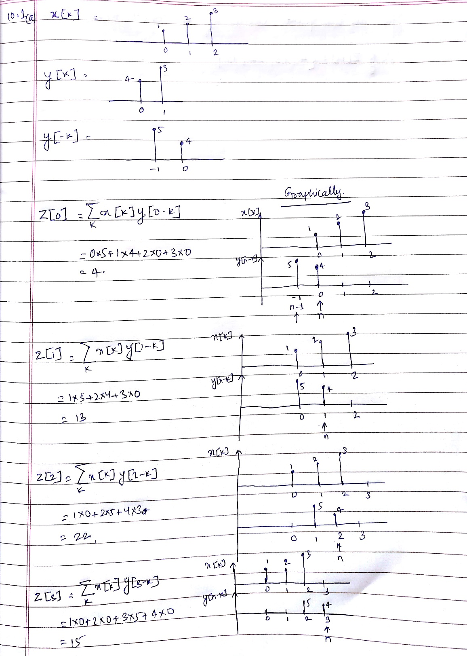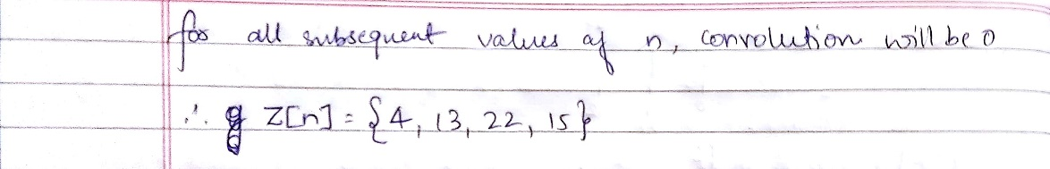



10.1 (b) convolution.m



This is the function which we will be using to calculate convolution



10.1 (c) convolution_script.m



From this we are calling convolution function.



